**ONLINE APPENDIX A: MODEL DETAILS**

**Model equations**

Landscapes and cell values:

In heterogeneous landscapes, a number of “hotspots” are assigned the maximum possible resource value and the remaining cell values are computed as:

(Equation 1)



where *V* is a cell’s resource value, *Vmax* is the resource value of hotspots, *DHotspot* is the distance of the cell from the nearest hotspot, and *Dmax* is the distance between the nearest hotspot and the furthest cell away from that hotspot. Hotspot “peakedness”, the rate of cell value decline with distance, varies according to the exponent, *P*; a value of *P*=1 indicates a linear decline of value with distance from the nearest hotspot.

Territory center location:

If a cell’s location on the landscape is written as vector, , each cell’s absolute resource value is designated by *V*, and a territory consists of *n* cells, then the location of the territory’s central point, , is simply the weighted average of the location vectors:

(Equation 2)



Value of cell to territory owner:

The realized valueof a territory cell to its owner,*Vterr*, is calculated as:

(Equation 3)



where *V* is the absolute resource value of the cell, *D* is distance of the cell from the territory’s central point, and *Rmax* is the maximum radius of the territory. The value of a territory is the sum of the *Vterr* values for every cell.

Territorial expansion: If the behavioral trait *territorial expansion* is turned on, the maximum radius (*Rmax*) is based upon group size, reflecting the cooperative ability of larger groups to defend larger territories.

(Equation 4)



where *Rsolitary*is the territory radius for a loneindividual and *N* is the number of adult individuals in the group.We set *Rsolitary* = 4 cells, corresponding to the 4 km mean territory radius of solitary females in the Serengeti National Park (Mosser and Packer 2009). This approximates a linear increase in territory area with an increase is group size (Macdonald 1983).

Territory attacks and defense:

Willingness to attack (*Wa*) or defend (*Wd*) a territory depends on relative group size:

(Equation 5)



where *Na* is the number of adult individuals in the attacking group and *Nd* is the number of adults in the defending group. For simplicity, we assume equal fighting ability of all individuals. A group will invade a neighbor’s territory if Wa ≥ 0.55, and defend against invasion if Wd ≥ 0.45, representing a weak advantage of prior ownership (Maynard Smith and Parker 1976). The winner of a contest is determined stochastically, with the probability of the attacking group winning beingdirectly proportional to group size. If cooperative defense is not present as a behavioral advantage, then each group has an equal probability of winning a contest.

**Sensitivity analysis**

In some cases, existing data did not provide sufficient information to set parameter values, sowe ran sensitivity analyses for key and uncertain parameters. We examined the results with respect to our central conclusions: 1) The proportion of social individuals increases with higher landscape values, 2) The proportion of the social individuals increases with greater landscape heterogeneity, 3) The proportion of social individuals increases when hotspots have a clustered, rather than random, distribution, 4) Cooperative defense is a necessary behavioral trait for the evolution of group territoriality, and5) Combinations of behavioral traits and landscape patterns produce synergistic effects. A summary of the results is presented in Table A3.

Modification of either the territory resource goal value or the addition of resources required per individual alters the nature of the transition from one group size toanother. When the resource goal of group size Nmatches the minimum for group size N+1, the transition is easier and thus increases the success of the social strategy.When territory goal values match minimum requirements for the next larger group size, the social genotype is favored in a wider range of circumstances, most notably in high value homogenous landscapes and when any two behavioral traits are present, thoughin some cases sociality is favored when only cooperative defense is present. This contrastswith the standard scenarios where sociality is only favored in heterogeneous landscapes where cooperative defense is combined with territorial inheritance. Biologically, the situation where the goal value matches the minimum value for a larger group is equivalent to a mother only reproducing when she has a large enough territory to support herself and her adult offspring.

The extent to which a territory might shift per year affects the speed at which territories can change, potentially altering the success of different territorial strategies. Similarly, the proportion of a territory that can be contested by a neighbor will affect the impact of intergroup contests: larger values might favor social groups. Altering the percent of territory movement per year increased the success of the social genotype in high value homogeneous landscapes, whereas altering the percent of territory contested had no effect.

Research on intergroup contests indicates that relative group size can affect the dynamics of the interaction in different ways. Lion fights most nearly follow a linear relationship (McComb, Packer, and Pusey 1994), meaning that conflict outcomes reflect a simple ratio of group size, which is how we designed the primary analysis. Other research, however, suggests that group interactions follow a *square law*, where relative group size enters the equation in a non-linear fashion and larger groups have an increasing advantage (Lanchester 1916; Franks and Partridge 1993; Wilson, Britton, and Franks 2002). We test this possibility by changingthe intergroup competition equations to:

(Equation 6)



However, changing this parameter had no effect on our central results.

Respect for prior ownership is common (Maynard Smith and Parker 1976; Kokko, Lopez-Sepulcre, and Morrell 2006) and thus attacking and defending thresholds were set to reflect this phenomenon.If attack thresholds arereduced, fights become more common and sociality can be favored with the possession of the cooperative defense behavior alone. Our results were otherwise unaffected.

When testing for lower and higher probabilities for fighting mortality,our sensitivity analyses revealed only one minor difference from our central conclusions: when the mortality rate of non-territorial individuals is set to 0, social individuals are somewhat more successful in homogenous landscapes, though the proportion of social individuals in the final populations remains less than 50%. Overall, our model conclusions were robust to changes in mortality rates.

In the primary analysis, the distribution oflitter sizes is 0.50, 0.35, and 0.15 for litters of size 1, 2, and 3, respectively. With maximum litter sizes of 1 or 2 (with a 0.5 probability of either 1 or 2 offspring in the latter case), the social genotype fares better than with larger litter sizes, even when a social strategy includes no behavioral advantages, suggesting that small litter size creates a rough equivalence between the two strategies.

Synergistic interactions were always present except when goal values met minimum requirements for the next larger group size.

**Table A1.** Parameter values

|  |  |  |  |
| --- | --- | --- | --- |
| Parameter | Primary analysis | Sensitivity analysis | References |
| Territory: |  |  |  |
| territory resource minimum | 1000 | - |  |
| territory resource goal | 1500 | 2000 |  |
| add. resources required per individual | 1000 | 500 |  |
| territory drop % per iteration | 0.25 | 0.05, 0.45 | unpublished data |
| solitary territory radius | 4 cells | - | Mosser et al., 2009 |
| Intergroup competition: |  |  |  |
| contested territory % | 0.25 | 0.05, 0.45 | Mosser, 2008 |
| group size modifier (*x*) | 1 | 2 | McComb et al., 1994 |
| attack/defend threshold | 0.55/0.45 | 0.50/0.50 | Maynard Smith et al., 1976 |
| fighting mortality | 0.05 | 0, 0.25 |  |
| Demographic rates: |  |  |  |
| no territory mortality | 0.5 | 0, 1 |  |
| background mortality | Table S2 | - | Packer et al., 1998 |
| orphan mortality | 0.75 | 0, 1 | Packer et al., 1988 |
| maximum litter size | 3 | 1, 2 | Packer et al., 1988 |

**Table A2.** Individual mortality rates by age in years

|  |  |
| --- | --- |
| Age | Mortality rate |
| 1 | 0.3 |
| 2 | 0.2 |
| 3 | 0.1 |
| 4 | 0.05 |
| 5 | 0.05 |
| 6 | 0.05 |
| 7 | 0.05 |
| 8 | 0.05 |
| 9 | 0.05 |
| 10 | 0.05 |
| 11 | 0.05 |
| 12 | 0.05 |
| 13 | 0.05 |
| 14 | 0.1 |
| 15 | 0.2 |
| 16 | 0.5 |
| 17+ | 0.9 |

Note: Based upon observed rates in Serengeti females (Packer, Tatar, and Collins 1998).

**Table A3.** Summary of sensitivity analyses with respect to central research conclusions.Regular values are within parentheses. Research conclusions: 1) The proportion of social individuals increases with higher landscape values, 2) the proportion of the social individuals increases with greater landscape heterogeneity, 3) the proportion of social individuals increases when hotspots have a power-law, rather than random, distribution, 4) cooperative defense is a necessary behavioral trait for the evolution of group territoriality, and 5) combinations of behavioral traits and landscape patterns produce synergistic effects. “-” = no qualitative change from results presented in the main text. Letters indicate a change from the original research conclusion; details are listed below the table.

|  |  |  |  |  |  |
| --- | --- | --- | --- | --- | --- |
| Tested parameter | 1) | 2) | 3) | 4) | 5) |
| Goal territory value equal to minimum for larger group size  (Goal less than minimum for next larger group) | - | a | - | c | d |
| Maximum percent territory change per time step = 5% (25%) | - | a | - | - | - |
| Maximum percent territory change per time step = 45% (25%) | - | b | - | - | - |
| Maximum percent contested territory per time step = 5% (25%) | - | - | - | - | - |
| Maximum percent contested territory per time step = 45% (25%) | - | - | - | - | - |
| Group size modifier (*x*) = 2 (1) | - | - | - | - | - |
| Attack and defend thresholds = 0.5 and 0.5 (0.55 and 0.45) | - | a | - | - | - |
| Attack and defend thresholds = 0.45 and 0.55 (0.55 and 0.45) | - | a | - | - | - |
| Non-territory mortality rate = 0 (0.5) | - | b | - | - | - |
| Non-territory mortality rate = 1 (0.5) | - | - | - | - | - |
| Orphan mortality rate = 0 (0.75) | - | - | - | - | - |
| Orphan mortality rate = 1 (0.75) | - | - | - | - | - |
| Fighting mortality rate = 0 (0.05) | - | - | - | - | - |
| Fighting mortality rate = 0.25 (0.05) | - | - | - | - | - |
| Maximum litter size = 1 (3) | - | a | - | - | - |
| Maximum litter size = 2 (3) | - | b | - | - | - |

1. Effects of heterogeneity on sociality only evident at low landscape values and sociality occurs at high percentages (>50%) in higher value homogeneous landscapes.
2. Effects of heterogeneity on sociality present at all landscape values yet sociality is present at low percentages (<50%) in higher value homogeneous landscapes.
3. Social genotype successful with cooperative defense or territorial inheritance alone.
4. Synergistic effect still present but less pronounced.



**Figure A1**. Power-law clustering of confluence hotspots is based on the inverse cumulative distribution for clusters of 1 to 6 hotspots, considering only adjacent (non-diagonal) grid cells in the identification of each cluster.



**Figure A2**. Map of lion pride territories in Serengeti study area for the year 2000 in relation to rivers and confluence. This example, along with maps from other years, demonstrates how territories are frequently centered around river confluences. Past research (Mosser et al. 2009) has shown that river confluences are the primary determinant of landscape value and reproductive success and function similar to “hot spots” as represented in our model. Territories represent the 75% kernel density estimate for all sightings of each pride throughout the year. Note that some pride territories are discontinuous. Territory ranges are grey regions outlined in black. Rivers are the thin black lines and confluences are the black dots. The grey outline is the edge of the study area.

**A**



**B**



**Figure A3**. A) Out of all intergroup interactions (n=215) that ended with some form of avoidance behavior, only 31 cases occurred between groups of the same age-sex class (males vs males, subadult females vs subadult females, etc.). In these matched groups, the outcome was strongly affected by relative group size: the larger group won in every case where the odds were at least three to one. B)The vast majority of intergroup encounters (n=168) involved mixtures of different age-sex classes, making precise comparisons impossible. However, because males could easily defeat groups with 1-2 times as many females (n=12 encounters) but were never seen to defeat groups with ≥3 times as many females (n=3), the relative strength of each adult male was assumed to be equivalent to 2.5 females. Maturing subadults were assumed to gain strength such that young females grew linearly from zero to 1.0 “female equivalent” between the ages of two and four years of age, whereas subadult males grew from 1.0 to 2.5 female equivalents between two and four years, owing to their greater body size. With these assumptions, the chance of winning an encounter increased with relative “adjusted” group size in virtually the same manner as for matched groups: a two-to-one ratio confers considerable competitive advantage while a three-to-one ratio almost inevitably wins.

This analysis ignores location – in the only two cases where weaker groups won despite being outnumbered by ≥3 to 1, singletons repelled itinerant groups that had temporarily ventured well out of their usual territories.

**A**

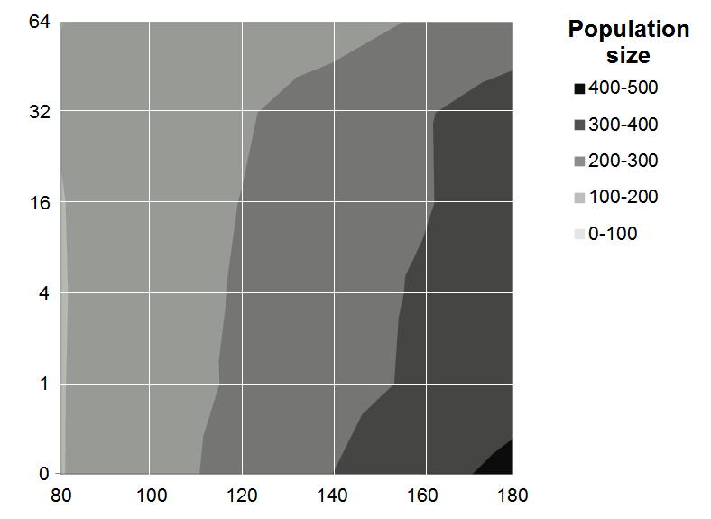

**B**

**Landscape heterogeneity**

**Landscape value**

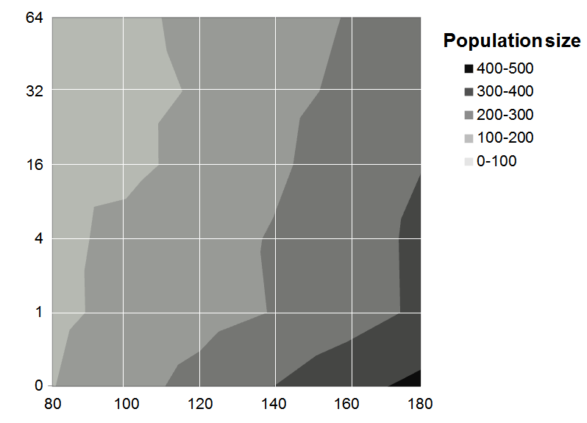

**Figure A4**. Population density as associated with landscape value and heterogeneity.

**References**

Franks NR, Partridge LW. 1993. Lanchester battles and the evolution of combat in ants. Animal Behaviour 45:197–199.

Kokko H, Lopez-Sepulcre A, Morrell LJ. 2006. From hawks and doves to self-consistent games of territorial behavior. The American Naturalist 167:901–912.

Lanchester FW. 1916. Aircraft in warfare: the dawn of the fourth arm. London: Constable.

Macdonald DW. 1983. The ecology of carnivore social behaviour. Nature 301:379–384.

Maynard Smith J, Parker GA. 1976. The logic of asymmetric contests. Animal Behaviour 24:159–175.

McComb K, Packer C, Pusey A. 1994. Roaring and numerical assessment in contests between groups of female lions, Panthera leo. Animal Behaviour 47:379–387.

Mosser, A. 2008. Group territoriality of the African lion: behavioral adaptation in a heterogeneous landscape. Ph.D. Thesis. University of Minnesota. St. Paul., Minnesota.

Mosser A, Fryxell J, Eberly L, Packer C. 2009. Serengeti real estate: density versus fitness-based indicators of lion habitat quality. Ecology Letters 12:1050–1060.

Mosser A, Packer C. 2009. Group territoriality and the benefits of sociality in the African lion, Panthera leo. Animal Behaviour 78:359–370.

Packer C, Herbst L, Pusey AE, Bygott JD, Hanby JP, Cairns SJ, Mulder MB. 1988. Reproductive success of lions. In: Reproductive success: Studies of individual variation in contrasting breeding systems. Chicago: University of Chicago Press. p. 363–383.

Packer C, Tatar M, Collins A. 1998. Reproductive cessation in female mammals. Nature 392:807–811.

Wilson ML, Britton NF, Franks NR. 2002. Chimpanzees and the mathematics of battle. Proceedings of the Royal Society London B 269:1107–1112.